Hallam Rear
R017093H@student.staffs.ac.uk
Particle simulation

Table of Contents
Introduction 2
Research 2
Project Methodologies 2
Agile 2
Waterfall 3
Rapid Application Development 3
Particle Simulation 4
What is Particle Simulation? 4
How is Particle Simulation used? 4
Problems with Particle Simulation 7
Realism 7
Efficiency 7
Graphics Frameworks 9
DirectX 9
OpenGL 9
Vulkan 10
Creating a Particle System 10
What does a Particle Simulation need to function? 10
Rendering system 12
Memory Management 13
Hydrodynamics 14
What is Hydrodynamics? 14
Principles of Fluid Dynamics 15
Navier-Stokes Equations 16
Smoothed-Particle Hydrodynamics 16
Smoothed-Particle Hydrodynamics using Navier-Stokes 17
Analysis 18
Design 19
Testing 25
White Box Testing 25
Black Box Testing 25
Grey Box Testing 26
Conclusion 28
References 30

Introduction
Particle systems are a computing technique commonly used in video game graphics and can also be used in the simulation of Physics phenomena with applications in both Physics and Engineering. They can be implemented in both 2D and 3D space and utilises sprites or models to achieve its effects. Smoothed Particle Hydrodynamics is a computational method for the simulation of continuum media. In this scenario, the continuum media in question are fluids and their respective flows. The project covers this simulation of a fluid through an implementation of a Smoothed Particle Hydrodynamic method to create a realistic representation in physics response and visual representation.

Research

Project Methodologies
Project methodologies are a set of processes which help manage the development of a project. They also help define how the team and client will interact. Each methodology has an ideal situation with their own advantages and disadvantages. The methodology to choose will be dependent on the size and type of the project as well as the size of the team. A project will need a methodology to help structure and maintain the development process. It helps to dictate a set of rules to follow during production to reduce confusion that may arise. It also helps to catch anyone up should there be any need to expand the team or add stakeholders to the project (West, 2018). The discussed methodologies are commonly used in industry and their usage is still discussed.

Agile
The Agile software methodology uses short development cycles, known as sprints, to allow for continual refinement while building the product. The sprints can last for several weeks and cover several stages (Smartsheet Inc, n.d.). These are:

- Requirements – The team defines the requirements for the iteration they are to produce. This includes any requirements that have been backlogged from previous sprints as well as requirements identified from customer/stakeholder feedback.
- Development – The software is designed and developed based upon the requirements defined in the stage beforehand.
- Testing – This covers all the testing for the software such as functional tests, unit tests and usability testing.
- Delivery – This stage is the integration of the current iteration into the existing piece of software.
- Feedback –This is where the feedback is taken from the customers and stakeholders which is then used in the next iteration of the software.

Agile development has various advantages such as its adaptability which is crucial in letting the clients understand what is being produced so that should they require any changes, they can be implemented in the next iteration of the project. Agile development also allows the product to be incredibly high quality given the ability to get feedback each sprint from the customer to constantly improve with each iteration (Smartsheet Inc, n.d.). However, with Agile development, the constant iterations mean that the developers cannot fully understand what is required from the start as the course of the software will change over time. This can unintendedly influence the design choices and may lead to internal frustration and poor practise. The constant iterations also mean that the projects require more time and resources to ensure that the client is fully satisfied with what is being produced. If they are not happy with the progress, then the project may fall behind schedule (Fridman, n.d.).

Waterfall
The Waterfall methodology is a more linear model of project development. It is one of the most widely used methodologies and consists of a set of distinct steps which are not progressed until they are fully completed (Team, n.d.). The main stages include:

- Requirements – A product requirements document (PRD) is produced containing all the requirements for the product. It defines the measurable goals for the product and includes but is not limited to functional, technical and usability requirements. It may also include any associated business information such as market data and success markers for the final product. Additionally, it is used to clarify the processes and tools that will be used during production to create a clear understanding of how the project will be produced (Catano, 1989).
- Design – During the design stage, high-level and detailed design documents are produced. A high-level design document is used to define the requirements from the previous step into the appropriate system components which the team can produce. It defines the various code practices, interfaces and structures that will be used in the development of the system. It also covers the test specification for the final product to be tested against.
- Implementation – This stage is the core construction and continued testing of the project. This stage can be improved based upon how well the previous stages were completed.
- Verification – This stage may also be known as the testing stage. It is the stage in which the testing of the written code is completed. It compares the produced software to the list of requirements provided by the first and second stages as well as ensuring that the client for the project is happy with the project. If there are any problems with what has been produced, then the process must return to the design stage and progress through the stages again.
- Maintenance – The final stage covers the long-term maintenance of the software and in this stage, you will also provide support regarding the software to the client.

The project only progresses when the current step is complete, and should the client require further changes to the application then the process should start from the very beginning. Waterfall development is thoroughly documented which helps with reducing the risk of misunderstandings as there is a clear and consistent set of goals for each stage, providing a clear-cut timeline and set of deliverables to be produced (Smartsheet Inc, n.d.). The Waterfall methods come with their own sets of disadvantages. For example, Waterfall cannot manage with changing requirements given its linearity. It will not return to the implementation stage if everything is continuing as planned and so requirement changes will not occur. As well as this, the software being created in Waterfall is not available working until late into the project lifecycle and can carry a lot of risks if it is not produced in the way in which the client intended but this should be very rare given its PRD (S, 2017).

Rapid Application Development
Rapid Application Development (RAD) is a methodology based upon four key stages (Team, n.d.).

- Requirements - A broad list of requirements for the software are planned as the specifics are realised later.
- Construction – A prototype is built as fast as possible to fit the requirements. It is not necessary for it to be polished, but to show certain features to the client.
- User Feedback – In this stage, the client is presented with the software and provides detailed feedback to the developers. It is not limited to function feedback but can also include usability or visual critiques.
- Finalisation – Once the program is finished, it is thoroughly tested, and the final product is produced. It is designed to be stable and maintainable.

The construction and user feedback stages are repeated until a final product is produced which fits the requirements for both the client and developer. This makes RAD very quick and flexible as the requirements can be changed at any point in development. It also helps improve client satisfaction as they have a strong and constant presence in the development cycle. However, for RAD to be viable, you need a skilled set of developers that are comfortable working in such an environment to fully utilise the efficiency of the methodology. Another drawback of RAD is that it is only viable for projects which are smaller in scope with a shorter overall development time. This is to avoid the client creating an unnecessary amount of work for the developers during each prototype production phase (Naz & Khan, 2015).

Particle Simulation

What is Particle Simulation?
Particle Simulation is a technique used to simulate physically based effects using many individual particles (Witkin, 1997). An individual particle is an object in 2D or 3D space which typically consists of a position, mass and velocity but can have additional individual characteristics which can be altered to replicate materials and when combined with an accurate collision response can be used to accurately simulate real-life interactions which can be difficult to properly observe, for example the simulation of granular materials such as sand. They can also be used as a visual effect to create the illusion of realistic properties. This is commonly found in film special effects and video games for systems such as particle emitters for fire and smoke (Sylvan, 2007).

How is Particle Simulation used?

Particle Simulation in Film
Particle simulation is commonly utilised in many ways. It is used to simulate fog and fire in special effects animations for Film and TV. The visual effects artists will use particle simulation to accurately recreate what would happen in their given scenario without putting any other staff in harm’s way using practical effects (Reeves, 1983).
Particle systems were initially developed by William Reeves in 1982 as an animation method for the movie Star Trek II: The Wrath of Khan (1982). The systems were used during this film to model a wall of fire surrounding an impact on a planet’s surface. There were multiple particle systems generated with various parameters based on their location, such as lifetime start and life duration, and then placed on the planet’s surface. Over time, these particles would grow following their respective parameters and create the effect of fire spreading across the surface (Reeves, 1983). Effects such as this are still used, for example, David Fincher & Digital Domain simulate blood splatters without the use of practical effects in the film Zodiac (2007). This allows them to recreate the effect of accurate blood splatters in their final production without forcing them to stop filming to reset the scene or clean-up any practical effects. As well as this Disney and Pixar continue to utilise particle simulation in their rendering systems for water, fire, dust, and smoke (Khan Academy, 2019) in their films including Finding Dory (2016).

Particle Simulation in Games
Particle simulation is also a recurring feature within video games. A particle system in video games commonly refers to an emitter of particles within the world (Zhang & Hu, 2017). These emitters exist within the game world and will create a customisable number of particles created within a game engine. The particles will exist for a specified amount of time and then be cleaned up when their end conditions are met (Zhang & Hu, 2017).
A common particle system is the built-in particle system for the Unity (Unity Technologies, 2020) game engine known as Shuriken. The Shuriken system allows users to fully customise particle settings and place them within the Unity world using their own emitters which are fully incorporated into the Unity component system. This amount of customisation allows users to create a wide range of unique effects such as sparks or smoke (Unity Technologies, 2020). Creating systems such as Shuriken is important in allowing artists to reproduce fuzzy effects accurately without needing to create an extensive amount of geometry with each draw call. This is important as it allows the system to limit the program resource load to ensure you can achieve maximum performance. For the current generation of console, games are expected to hit at least 60 frames per second. This is based upon the older analogue TVs and monitor which ran at 60Hz in the US/Canada where a large amount of game development studios and computer manufacturing companies were initially based. This frequency was drawn from the electricity grid rate and so was a solid baseline to use for synchronisation. Continuing the 60fps trend is important to a good user experience as it allows for a smoother motion within the video (Armstrong, et al., 2008).
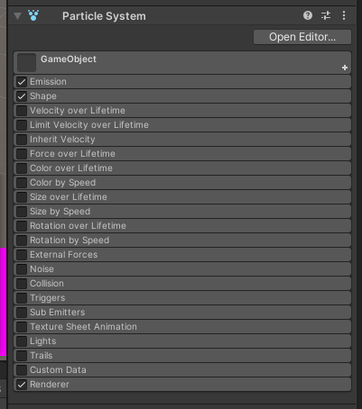
Figure 1 - Screenshot from Unity 2019.4.15f1 (Unity Technologies, 2020) showing a particle system component.

Modern examples of particle simulation within video games include games such as Noita (Nolla Games, 2020). Noita is an action rogue-lite created by Nolla Games and released on the 15th October 2020 in which you play as a witch fighting through a procedurally generated world to get to the base of a cave system to defeat an evil boss (Nolla Games, 2020). Noita’s unique gameplay comes from the fact that its game world is ‘fully physically simulated’. Simulating solids, liquids, and gases as pixels within the game to use as a gameplay element including water, ice, sand, lava, smoke, and other materials. The simulation also includes a rigid body system for objects not bound to the tile format. The objects are created, and an outline is generated using a Marching Squares algorithm to define the collision shape (Maple, 2003) and followed up by the Ramer-Douglas-Peucker algorithm (Douglas & Peucker, 1973) to reduce the number of vertices in the mesh (Purho, 2019).
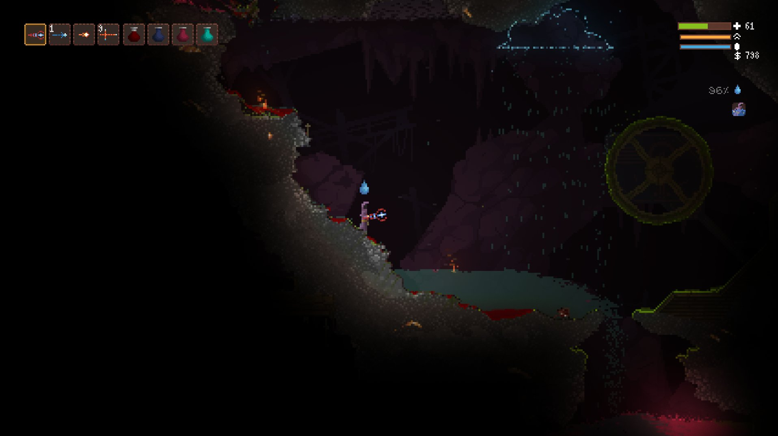
Figure 2 – Screenshot from Noita (Nolla Games, 2020) showing water flowing off a cliff edge.

The advantages of using this combination of simulations allows Nolla to create as realistic of a game world as possible which the player can recognise due to their understanding of how the substances react in the real world (where applicable). The player can then use this understanding to develop their in-game ability and to help manipulate the geometry to understand how the materials interact with each other.
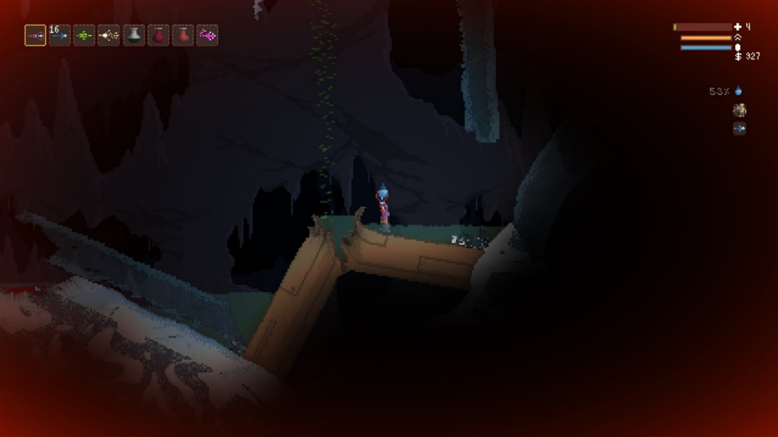
Figure 3 – Screenshot of Noita (Nolla Games, 2020) screenshot showing a flammable gas leaking out of a pipe.

Problems with Particle Simulation

Realism
One of the uses of particle simulations is to reproduce realistic looking phenomena, such as fire, smoke, or water. It can be difficult to produce such effects due to their complexity and so there is often a compromise on their accuracy. To minimise on this, particle simulations will give the users many settings to modify within their environment to allow them to fine tune the effects themselves. This helps the users as it means they can visualise something exactly how they want, which can be incredibly useful if the effect they are looking to create does not exist within the real world. The perception of a realistic simulation by the viewer is the most important thing and the users can use that to their advantage in such a scenario (Ginman & Malmros, 2013).
For example, in Star Trek II: The Wrath of Khan (1982), a moon-like baron planet is shown being engulfed by a fire wall and turning into a warm, brighter planet. Each frame is broken into individual elements and each edited then pre-rendered to be composited together when all are complete. Producing such an effect in this way allows each element to be edited individually to create a realistic (for the time) effect of fire and how it would interact with the atmosphere with both elements being completely customisable. This would mean that should the production company or director decided to change something within the scene, only a single element needs to be adjusted then recomposited and the effect can be sustained. When designing the wall of fire effect for this scene, the particle system created generated a series of particle systems in which the top level was the point of impact for this bomb. The particles it generated created their own sub particle systems which represented the fire rings around the planets. The particle systems overlapping with themselves and the neighbouring rings gave the firewall a solid appearance for the cameras flyby. As well as this, the production team added in post-process effects to the pre-rendered scene which helped to build upon the apparent solidity of the fire by blurring the edges of the flames, as if to mimic heat distortion in the upper atmosphere (Reeves, 1983).

Efficiency
Particle simulations with an extremely large number of particles can be very slow to update which can ruin the look of a realistic simulation. One of the ways to improve the speed of a simulation is to use an algorithm to reduce the number of checks each particle must make.
An example of one of these algorithms is the Quadtree algorithm. A Quadtree is a tree data structure in which each node in the structure has exactly four children. They are used to split 2D space by repeatedly subdividing regions known as buckets into four subregions with each subregion having a maximum capacity. When objects are added to the buckets, they check to see if they have reached this maximum capacity and if so, the bucket splits (Finkel & Bentley, 1974). The 3D implementation of this algorithm is known as an Octree. In an Octree every internal node has 8 children (Meagher, 1980).
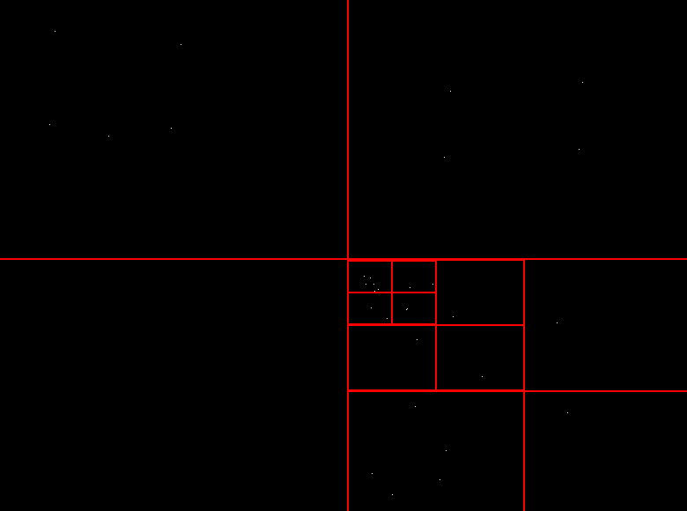

Figure 4 - A screenshot of a Quadtree implementation showing the various bucket splits.

The Quadtree algorithm allows the particle simulation to reduce the number of collisions checks between particles by eliminating a vast amount of possible collision space around a given particle. A particle on one side of the world would not be expected to collide with one on the opposite side and so performing a check such as a collision calculation between them would be a waste of computing resources.
Test set | T0 | T1 | T2 | T3 | T4 | T5 | T6 | T7 | T8 | T9 | T10
Object count | 2 | 18 | 50 | 98 | 162 | 242 | 338 | 450 | 578 | 722 | 882
N = 5 | 2.55 | 12.1 | 33.9 | 72.9 | 120 | 192 | 255 | 344 | 447 | 571 | 726
N = 10 | 2.85 | 11.8 | 34.3 | 70.8 | 118 | 178 | 246 | 333 | 448 | 559 | 688
N = 30 | 2.77 | 13.6 | 33.7 | 70.3 | 117 | 181 | 250 | 337 | 443 | 550 | 693
N = 50 | 2.86 | 12.2 | 33.9 | 72.1 | 116 | 178 | 250 | 337 | 443 | 559 | 974
N = big | 2.49 | 11.9 | 33.6 | 69.2 | 116 | 183 | 266 | 377 | 474 | 625 | 791

Table 1 - Time in seconds to compute dynamics and collision detection for 200 time steps for each test set (Swan II, 1994).
When deciding whether to use a Quadtree, you should first consider if the application you are creating would benefit from its implementation. For example, a game which contains only a handful of objects may not utilise the Quadtree as well as the same game with thousands of objects. This is because the initial scenario would run search algorithms and return results at a similar speed to if they were searching an array without a Quadtree. As well as this, design also dictates if you use a Quadtree or Octree. Typically, 3D environments would use an Octree as the extra dimension requires an extra level of spatial partitioning that is provided by the third axis and extra buckets of the Octree’s representation. Octrees can also be used within rendering scene graphs to help perform culling as you can utilise a Quadtree to find each node that is visible to the camera.
Another example of space efficiency is a spatial hashing implementation. Spatial hashing is a process in which objects in either 2D or 3D space are placed into a 1D hash table to allow for faster location queries. To implement this, you need a hash function and a hash table (Hastings, et al., 2005).
A hash function is a function which is used to map a key to a reproduceable unique hash. A hash table (or hash map) is a data structure which uses the hash function to compute indexes for an array of objects. Hash tables are incredibly useful as they provide a fast way to access data within an array irrespective of its size as the index is retrievable extremely quickly. Hash tables should be used when a quick search is required within large amounts of data, although the amount of data you have would depend on what sort of hash table you should use. Overall, a hash table provides a quick and straightforward way of locating individual array elements and has a best-case search speed of O(1) and a worst-case time complexity of O(n) (Cormen, et al., 1989). Resizing the hash table which should be avoided as much as possible as this requires a reallocation of the element array and transfer of the original content to it which is a waste of computation and memory usage time. To avoid this, you should allocate a much larger amount of memory if you are expecting to increase the amount of data you have stored. You should also avoid using a hash table for data that needs to be sorted as the hash function will more than likely not produce an index sequentially.

Graphics Frameworks
For the creation of this simulation, a graphics framework will need to be selected for the rendering system. It is important to choose the correct framework as it has a large effect on the performance of the system, which for this current project is a key element. The main frameworks used as of writing (Foley, 2015) are:

DirectX
DirectX is the name of a compilation of APIs used for various multimedia tasks such as user input detection, graphics and text rendering and sound manipulation. Originally released in 1995, DirectX has been a core framework for users to develop modern programs and so has be subject to constant iteration to improve efficiency. The most common components of DirectX used include:
- Direct3D (D3D) – Real-time 3D rendering.
- DXGI – Monitor enumeration and swap chain manager for D3D 10 and later.
- Direct2D – 2D graphics rendering.
- DirectWrite – Text rendering.
- XACT3 – High-level audio.
The most up to date version of the DirectX framework is known as DirectX 12. DirectX 12 was designed to be faster than previous versions of DirectX by utilising multi-core CPUs more efficiently through a lower level of hardware abstraction (Olofsson, 2016). As well as this, DirectX 12 releases GPU overhead from the programs by making developers responsible for their own memory management systems. Compared to the previous release, DirectX 12 improves GPU efficiency by up to twenty percent and runs with a significantly reduced power consumption. Despite this, a large collection of modern projects will still utilise the previous version, DirectX 11. Its long-term usage in the industry makes it an easier framework to build upon given the previous experience companies may have. As well as this, DirectX 12’s lower-level abstraction creates a need for more code for the same amount of work when compared to DirectX11 and so for smaller projects, such as this one, using DirectX 12 may be a waste of code production time (Microsoft, 2015).

OpenGL
OpenGL or the Open Graphics Library is a cross language API for rendering both 2D and 3D graphics. Originally released in 1992 by Silicon Graphics, OpenGL became a strong framework for developing 3D programs such as those for computer aided design (CAD) and video games. The framework became a direct competitor for DirectX when it was released in 1995 despite an attempt from game developers to unify the frameworks (Peddie, 2012). OpenGL is currently in version 4.6 and currently maintained by the nonprofit Khronos Group. However, unlike DirectX, OpenGL has many offshoot toolkits and libraries to cover the issues created by only being a rendering API. These cover problems such as window creation and input management. An example of a few of these libraries (Khronos Group, n.d.) include:

- GLFW – Windowing and basic input handling.
- freeglut – Stable and up to date version of GLUT (OpenGL Utility Toolkit).
- SFML – Multimedia library with C++ API with bindings for other languages.
- SDL – Multimedia library.

OpenGL is usually associated with video games given its usage in their development. This is because OpenGL is a hardware independent API and so creating games using it can allow for cross platform games and allow for ease of porting between platforms. This also means that a large amount of the code between platforms is reusable, which can reduce the development time for projects (Anthony, 2012).

Vulkan
Vulkan is a cross-platform 3D graphics and compute API developed by AMD and the Khronos Group. Initially released in 2016, Vulkan is a separate API to OpenGL despite being maintained by the same company. Vulkan is a completed redesign from the bottom-up and designed for modern hardware with a much steeper learning curve compared to OpenGL (Ekstrand, 2016). This redesigned also gives Vulkan much simpler drivers compared to other graphics frameworks, reducing bottlenecking of the CPU, reducing latency, and improving the portability of the framework. The major differences from Vulkan and its competitors are that the memory allocation, thread generation and management are offset into the application code rather than the drivers or their abstractions. This allows the developers a greater deal of flexibility when it comes to fully utilising hardware as they can define what is to be used. This paired with the multi-threading of the command buffers allows for a much more efficient rendering cycle when compared to the OpenGL single thread per context (Khronos Group, 2016).

Creating a Particle System

What does a Particle Simulation need to function?
To understand what a particle system needs to function, the definitions used for each of the terms needs to be clear.
- Particle – A singular object in 2D or 3D space. They are comprised of at least a position, velocity and a lifetime and can be affected by forces such as gravity or friction. Each particle can have additional features such as bounciness or an individual collision profile to enhance the overall system (Sylvan, 2007).
- Particle system / Particle manager – The term for the management system for the individual particles over time. The particles are created, update, and be destroyed inside the system (Reeves, 1983).
- Particle emitter – An in-engine object to represent the creation of individual particles for the particle system, inside the game world.
- Particle simulation – The name for the overall process of using several particles to replicate a fuzzy effect.
The particle life cycle starts with a creation of a mass of individual particles within the particle system. Each particle can be given specific or random values to start with and is then updated as the program runs. With each update cycle, each particle has their lifetime increased by the time that has elapsed. Once a particle has exceeded its set lifespan, it is then flagged as ‘dead’ or inactive. Once this happens, then the particle system can utilise the memory to create a new particle in place of the ‘dead’ one. This is an effective use of an object pool. Object pools are an optimisation programming pattern used to improve the performance of a project through the reuse of individual objects from a fixed pool rather than rapidly allocating and deallocating memory. Object pools also help with reducing memory fragmentation within the program. Memory fragmentation is when memory is scattered into non-contiguous blocks and so cannot be used to reserve the full requested amount. If a large amount of memory is fragmented, then it may be impossible to access fully.
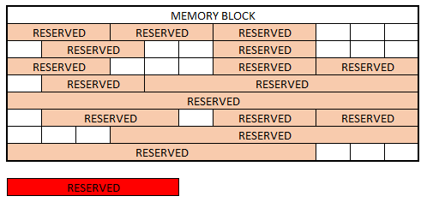
As memory fragmentation can make it hard to reallocate large amounts of memory later, and the calls for memory allocation can be slow then it is safer for a program to allocate a mass of memory to utilise (Nystrom, 2014). Using an object pool when creating a particle system is highly recommended as they are not difficult to implement and are worth implementing for the reduction of allocation/deallocation calls.
Figure 5 - Diagram showing memory fragmentation. The red section cannot fit within the memory block as the memory gaps are not large enough.

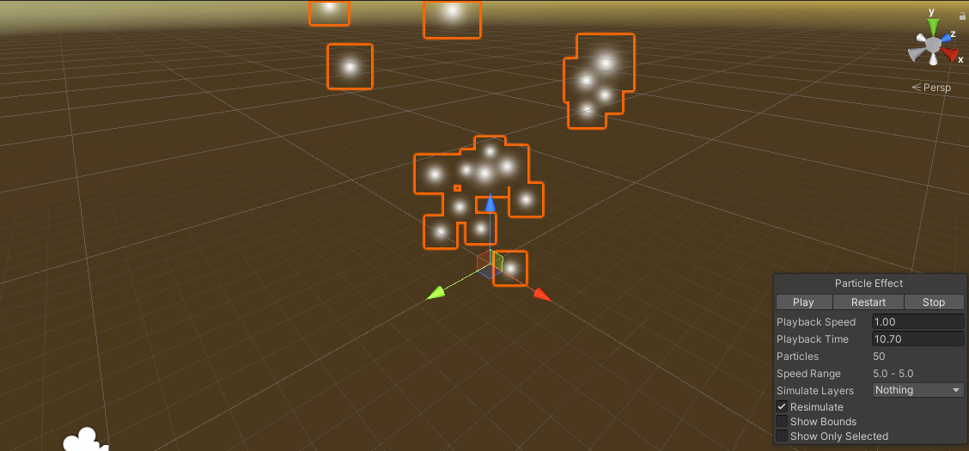
Figure 6 - Unity particle emitter object inside the engine and its associated component.
Particle emitters are objects contained within a simulation or game world that allow the creation of spawning of particles. In the Unity particle system, you can add a particle emitter as an object to the game world through a toolbar or you can attach a particle system engine component to an object (Unity Technologies, 2020). This allows you to use the system anywhere within the engine to maximise its capability. It also allows artists to work on a specific particle effect without having to worry about getting in the way of the rest of the project as they can copy the component. The straightforward access to the variables is one of the ways that makes the Unity system such a beginner friendly system.

Rendering System
Particle systems need a way to represent themselves on the screen. When rendering thousands of particles at once, the rendering system is something that contributes near enough everything to the application. A particle system is hard to visualise when it is just a series of numbers. There are various techniques that can be utilised when rendering a particle system to improve performance and looks.
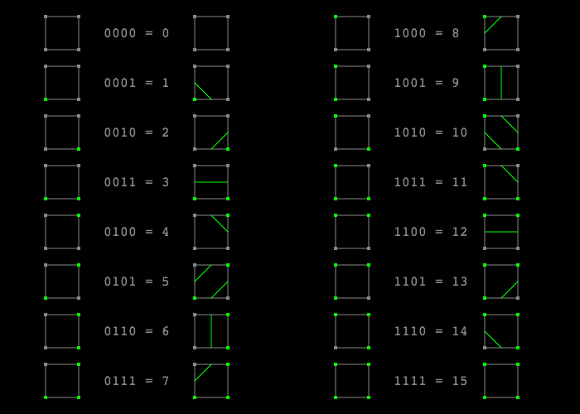
Instancing is a method of drawing multiple models containing the same set of vertex data but with different world transformations. It is commonly used for rendering grass and leaves. For particle systems, this is an incredibly useful feature for rendering (Park & Han, 2008). Having thousands of draw calls can slow down the application as each command is sent to the GPU individually, by using instancing we tell the GPU in a single draw call how many instances of a model we want and pass through the data for where to put them. This minimises the number of state changes within the application to a singular call, reducing time that the CPU spends submitting those changes to the GPU (Kang & Liang, 2019). Multiple particles can be grouped together and rendered as a single entity to allow for more diverse simulations. The Marching Squares algorithm (Maple, 2003) is a technique for rendering surfaces using contours over a grid. This helps communicate what the data is showing visually rather than as a set of numbers. It does this effectively by assigning each vertex of a scalar grid a value (or weight). They can be defined as any value but for this example, they shall be defined as 0 or 1. A predetermined set of cases for each grid square and its associated four values are used to represent all the possible arrangements of zero and ones within the square. If the value at each vertex is calculated based upon the presence of a particle from the particle simulation, one being yes and zero being no, then an outline is formed around the particle system.
Figure 7 - An example of all Marching Square combination cases (Wong, 2014).
The maximum number of combinations for zeros and ones in the corners is 16. A square within an outline of ABCD ordered from anti-clockwise from the bottom left, and all four corner values equating to zero would produce a grid case of 0000. The same square with all four corners having a value of 1 produces a grid case of 1111, the binary value of 15. This allows each combination of corner values to have a representable grid case (Gong & Newman, 2016).
Metaballs are isosurfaces identifiable by their ability to merge when they get close to each other to create singular objects. They also need to be stored in a uniform 3D grid. Each frame, the value for each grid point is calculated using a function taking in the position of the defining balls. A threshold value is chosen, and the volume is defined as within the solid volume when the function return is higher or lower than the threshold. These values can then be used by the Marching Squares or Marching Cubes algorithms to create an outline for the data (Steen, 2020). Using these in conjunction allows for a more realistic approach to replicating materials that have a high viscosity and appear ‘thicker’ and unwilling to split such as honey.

Memory Management
An object pool maintains a collection of preallocated objects which are to be reused rather than creating and destroying objects at runtime. Each object contains a method of checking if it is still active or ‘alive’. The object pool is initialised and creates many objects in a single contiguous allocation of memory for the pool. It creates every object within the pool in an inactive state. Creating an object pool means that when creating and removing objects from the pool you are not directly interacting with the memory. Instead, the object pool is queried for a free object and searches its collection for one. If it can find one, it will set the objects flag to alive or in-use and returns the object to the user like usual. When the user no longer requires the object, they inform the object pool, and its state is set back to dead or ‘not-in-use’. Using this approach, means that objects can be seemingly created and destroyed by the system quicker as there is no allocation of additional resources (Liang, et al., 2010). The most common usage of objects pools is within games for entities or particle effects. This is because the object pool is best utilised in programs which require a large amount of creation and deletion of objects which are similar in size. This helps the developer to avoid allocating massive amounts of objects to the heap at runtime as this is slow and increases the risk of memory fragmentation. However, using an object pool still contains risk. The size of an object pool is important and should be altered to suit the project. There is not a perfect size of object pool to cover all projects. An object pool that is too big is wasting memory with objects that are never used, but an object pool that is too small may crash the program. This view also applies to the objects within a pool. The memory size of each object within the pool may be varied based on the implementation. Each object slot in the memory pool should be able to accommodate the largest of the possible objects which can be ‘created’ by the pool. This can lead to memory waste within the pool by putting smaller objects in memory allocated for larger ones (Nystrom, 2014).

Hydrodynamics

What is Hydrodynamics?
Hydrodynamics is a field of study that focusses on the study of liquids in motion. It is a subdiscipline of fluid dynamics. The difference being that fluid dynamics covers the study of the flow of both liquids and gases.
Throughout, the definitions of the states of substance below shall be used unless expressed otherwise:
- Gas – Substances which will take on both the shape and volume of a container.
- Liquid – Substances which will retain its volume but still take on the shape of the container.
- Fluids – Both liquids and gases. A fluid will continually flow and deform when a shear force is applied to it.
Fluid dynamics are used in a wide range of applications such as testing models of forces applied to aircraft during flight or calculating the flow rate and change of pressure of liquids through pipes. Fluid dynamics, and in turn Hydrodynamics, solve problems through calculations involving various properties of the subject fluids. Common attributes mentioned include:
- Pressure – The force exerted perpendicular to an object or surface over an area, measured in pascals (Pa) and commonly represented by ‘p’ or ‘P’.
- Density – The mass of an object per unit of volume. This is calculated as $ρ= \frac{m}{V}$ where ρ is the density, m is the mass, and V is the volume of the substance. Density can also be represented by ‘D’ and is given as kg/m² .
- Velocity – The rate of change in position, over time. The average velocity is calculated using $v= \frac{∆s}{∆t}$ where v is the velocity, Δs is the change in position and Δt is the change in time. Different equations may be used if the problem requires a velocity at a specific timepoint as this equation only provides the average velocity over the period and does not account for changes in acceleration. Velocity is given in metres per second (m/s).
- Viscosity – The measure of the resistance to deformation. ‘Thickness’ is the colloquial term for viscosity in fluids. Fluids such as honey have a higher viscosity than water. The commonly used symbols for viscosity are η and μ.

Principles of Fluid Dynamics
Particles within a flowing flow will change their position due to their velocity. The distinctions between the types of flow are taken from this. Laminar flow refers to a flow of a fluid in a regular manner with no fluctuations. The velocity and pressure remain constant for the fluid when in laminar flow. To visualise laminar flow, it is often shown as horizontal layers all parallel to each other and sliding along each other. Laminar flow is common in scenarios in which the fluid is moving at a slow speed or its viscosity is very high (Encyclopedia Britannica, 2018). Turbulent flow is the opposite. The flow is chaotic and is characterized by its fluctuations in pressure and flow velocity.
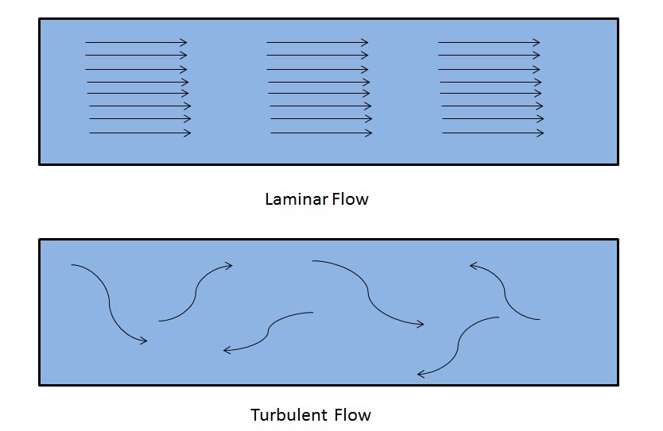
Figure 8 - Diagrams of Laminar and Turbulent Flow

When the fluids velocity does not change during flow at a fixed point then the flow is known as a steady flow. Given the nature of a turbulent flow, this is not the case and so turbulent flows are considered unsteady. A key difference between the steady and unsteady flows is that the properties on an unsteady flow depend on time (Pope, 2000). The flow pattern can also be represented through its Reynold number.
A Reynolds number is used to predict patterns in a flow in various scenarios. The value produced through the calculation of the Reynolds number represents the ratio of inertial and viscous forces. Low Reynolds numbers typically represent laminar flow meanwhile higher Reynolds numbers represent turbulent flow (NASA, 2014).

The equation for calculating a Reynolds number is:
$$R_{e}=\frac{VL}{v}= \frac{ρVL}{μ} v= \frac{μ}{ρ}$$
Where:
- $ρ-density (Kg/m^{3})$
- $V-flow velocity (m/s)$
- $L-length \left(m\right)$
- $μ-bulk viscosity (Pa·s)$
- $v-kinematic viscosity (m^{2}/s)$

Navier-Stokes Equations
The Navier-Stokes equations are a set of partial differential equations that are considered fundamental equations in fluid dynamics as they are used to describe how incompressible fluids flow through in different scenarios. They are used extensively in various industries that will utilise fluid flow. For example, the equations are used to model ocean currents but can also be applied to blood flow through the body.
The Navier-Stokes equations in vector form are $∇∙\underline{u}=0$ and $ρ\frac{D\underline{u}}{Dt}= -∇p+ μ∇^{2}\underline{u}+ ρ\underline{F}$ (Munson, et al., 2013).
The first equation, $∇∙\underline{u}=0$, defines the divergence of the vector field for velocity vector $\underline{u}$ equal to zero. $∇∙\underline{u}$ can be represented as the sum of the differentiated parts of the vector and therefore:
$∇∙\underline{u}$ = $\frac{Du}{Dx}+ \frac{Dv}{Dy}+ \frac{Dw}{Dz}$ = 0 with vector $\underline{u}=(u, v , w)$
With this equating to zero, it shows that there has been no mass created or lost as there is no change in velocity in the vector field and no flow from a source point.

The second equation $ρ\frac{D\underline{u}}{Dt}= -∇p+ μ∇^{2}\underline{u}+ ρ\underline{F}$ represents the conservation of momentum. The left-hand side of the equation $ρ\frac{D\underline{u}}{Dt}$ represents the mass times by the acceleration taken from Newton’s second law, $\sum{F}=ma$ when applied to fluid motion (Munson, et al., 2013). The derivation of$D\underline{u}$ over time is the calculation of velocity and the density of the fluid is represented in the calculation using $ρ$. The right-hand side of the Navier-Stokes equation $-∇p+ μ∇^{2}\underline{u}+ ρ\underline{F}$ is equivalent to the forces being applied in the fluid. It can be broken down to demonstrate the key components of the equation. The first two elements $-∇p+ μ∇^{2}\underline{u}$ represent the internal forces of the fluid. $∇p$ is the gradient pressure force applied from the internal fluid movement caused by the difference in pressure between two points in the container. For example, when air moves from a high-pressure area to a low pressure one until the overall pressure is equal. The second element $μ∇^{2}\underline{u}$represents the internal stress of the fluid with$μ$ in this section representing the fluid’s viscosity. A higher viscosity fluid requires more force to move and vice versa. The final element $ρ\underline{F}$ represents the external forces, such as gravity, applied onto the fluid.
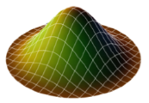

Smoothed-Particle Hydrodynamics
Smoothed Particle Hydrodynamics (SPH) is a numerical method for simulation of Hydrodynamic problems. Originally developed to solve astrological problems, SPH has been expanded to include the study and simulation of fluid flows with large deformations (Liu & Liu, 2003). This is because as an adaptive, meshfree particle method, SPH can be used to simulate the combined movement of fluids using Newtonian Hydrodynamics in a similar way Lucy, Gingold and Minaghan equated their astrophysical solutions (Lucy, 1977) (Gingold & Monaghan, 1977). At the core, SPH covers the smoothing of particle attributes.
Figure 9 (above) - poly6 kernel representation (Wongpanich & Jow, n.d.)
Smoothed Particle Hydrodynamics uses a Gaussian-like function, known as a kernel function, to smooth its particle representation. The smoothing kernel defines a scalar weight $W$given the distance $r$ from the position of a particular particle $ⅈ$, creating a symmetric kernel distribution around it. A smoothing constant is required to calculate which of the particles within a distance around $ⅈ$ should be used in the calculations on the particle. This distance will be represented using $d$ (Van Verth, 2010).
For example, poly6 is a kernel used for smoothing. The poly6 kernel equation looks like this:

$$W_{poly^{6}}\left(r\right)=\frac{315}{64πd^{9}}\{\begin{matrix}{\left(d^{2}-r^{2}\right)}^{3} \\ 0\end{matrix} \begin{matrix}0≤r ≤d \\ otherwise,\end{matrix}$$

The kernel can be used in the computation of a smoothed density field. The kernel function will need to be normalized i.e., $\int{W}\left(\left|{(x- x}_{i}\right|\right)dx=1$ (Müller-Fischer & Bridson, 2007). If not, in the calculation of a density field the density of a particle will result in $ρ_{i}={ρ(x}_{i})$ which is not what is expected. When it is normalised however, the density can be calculated using:
$$ρ_{i}= \sum_{j}{m_{j}W(r)}$$
When the particles are given their physical properties (mass, density, etc.), the smoothed density field values of the particles are then used to calculate the smoothed values $A_{s}$ of a particle’s attributes $A_{i}$ (Müller, et al., 2003).
$$A_{s}\left(x\right)= \sum_{j}{m_{j} \frac{A^{j}}{ρ^{j}} W (}r)$$

Smoothed-Particle Hydrodynamics using Navier-Stokes
The equations to derive various variables for a particle can be taken from the SPH equations. The internal forces of the fluids taken from Navier-Stokes can be equated to that of an SPH equation altered to produce a gradient.
$${∇A}_{s}\left(x\right)= \sum_{j}{m_{j} \frac{A^{j}}{ρ^{j}} ∇W (}r)$$
The pressure for a given particle can be calculated by altering the kernel weight to a gradient of the kernel which will in turn give us the gradient of a particle’s attributes. For example, to find the pressure of particle $A_{i}$ we can calculate the pressure element of Navier-Stokes as this gradient supplement equation.
$$A_{i}(pressure)= -∇p(x_{i})= -\sum_{j}{m_{j} \frac{p^{j}}{ρ^{j}} ∇W (}r)$$
However, the force calculated from this equation is not symmetrical. The kernel gradient at the centre of the distribution causes $ρ_{i}$ to use the pressure of $ρ_{j}$ exclusively in its pressure calculations. Given that these pressures calculated are not equal, the pressure forces are not symmetric and so this equation can be used to ensure a two-particle interaction can be equal (Van Verth, 2010).
$$A_{i}(pressure)= -∇p(x_{i})= -\sum_{j}{m_{j} \frac{p^{i}+p^{j}}{2ρ^{j}} ∇W (}r)$$
Similarly, we can calculate the viscosity of the individual particle using the squared gradient equation and rearranging the SPH to the second element of Navier-Stokes. $v$ is used to represent the velocity as the viscosity forces are dependent on a difference between velocities in the particles.
$$A_{i}(viscosity)= μ∇^{2}v\left(x_{i}\right)= μ\sum_{j}{m_{j} \frac{v^{j}}{ρ^{j}} ∇^{2}W (}r)$$
The viscosity equation can also produce asymmetric results and so we can solve this in a similar fashion to the pressure.
$$A_{i}\left(viscosity\right)= μ∇^{2}v\left(x_{i}\right)= μ\sum_{j}{m_{j} \frac{v^{j}-v^{i}}{ρ^{j}} ∇^{2}W (}r)$$

Finally, the external forces used within the Navier-Stokes equations can be applied to the individual particles directly similarly to traditional particle systems (Schuermann, 2016).

Analysis
This section of the document is the analysis of the research presented. This section will also cover the final decisions of what to use for various aspects of the system. This will help to clarify what is required of the final product before the design and development.
Given the research covering project methodologies, the most appropriate methodology to use for this scenario would be the Rapid Application Development (RAD) methodology. This methodology requires a small project and allows for a large amount of flexibility throughout development. This allows the developers to reassess their choices throughout development during regular meetings or scrums to ensure the correct path is being taken. As well as this, regularly meeting allows for all developers to stay up to date on what is being worked on and allows for a constant feedback for anything that may have been missed in the initial stages. The rigidness of the documentation required by the Waterfall method makes it very difficult to make changes to the requirements during development without needing to alter the overall timeframe and disrupt developer workflow. Furthermore, Agile development can also become disrupted by unexpected features which are not initially mentioned by the client. The client’s requirements may cause the development sprints to increase dramatically given the scope of the additions. Rapid Application Development mitigates this problem by iterating in smaller sprints consistently and allowing for regular meetings with clients to locate missing elements as soon as possible. As well as this, RAD produces iterations which include functional features for the clients to discuss and test to ensure they are happy with what is being produced before beginning developments on the visual aspects.
For this project, OpenGL would be the most appropriate choice for a rendering framework. This is due to its portability and ease of use compared to the other lower-level frameworks. The lower entry level of OpenGL allows for faster project production times given the availability of tutorials and other resources to help understanding the API. Compared to DX12 or Vulkan, the difference in speed between the frameworks is so small for this project that there would be no point in producing much more code for the same outcome. Using OpenGL also opens the possibility of incorporating various libraries to offload some of the code during production (Khronos Group, n.d.). With the graphic framework implemented, the algorithms used to render the solution have been chosen specifically for this project. The Marching Squares algorithm (Gong & Newman, 2016) is a rendering technique for the creation of contours over a grid. It is an appropriate algorithm for the task at hand as it can be used to render the fluid surface efficiently. The efficiency comes from the use of its predetermined set of scenario cases and the minimal overhead the algorithm creates as it can use exclusively existing data to create its weight values. The predetermined set of cases also reduce the draw times as they are repeatedly called and are not changed throughout the program.
The solution cannot exist without particles to fill the scene and so implementing a form of particle system is a key part of this simulation. Implementing a particle manager would allow for the program to consistently keep track of particles in memory to avoid any memory leaks or excessive allocation. Combining this with a memory pool can help to reduce the risks of any memory issues as we are only allocating a limited amount of memory and constantly reusing preallocated particles. This also allows us to control the extent that the user can push the program when they are adding particles. This can be achieved using particle emitters, making them an important part of this program. They will allow the user to add the new particles to the simulation and in turn with an editable set of properties for each particle, maximize the potential of the simulation. Adding this feature allows the user to experiment with the materials and fluids which improves the user experience.
For this project, representing the materials correctly is also a key part to creating a realistic simulation. A goal of this project should be to produce a smaller number of materials accurately rather than trying to fit a large selection in. The materials to be recreated should be able to fit into 4 groups:
- Static materials – These are objects within the world that do not have any physics responses. They are placeable in the world and cannot be shifted by any materials.
- Heavy materials – Heavy objects would simulate those in real life which sink when reacting with water. E.g., solid metals.
- Light materials – Light materials simulate those than float on water and do not mix such as oil.
- Sediment solids – solids that can break up into smaller individual particles that can rest and clump together.
- Liquids – Such as Water.
These four groups should cover the vast number of possible materials to implement and with good class design the implementation of any new materials would not take very long. This helps prepare the project for future expansion. Each material regardless of their type should contain a set of common property variables that are used within the physics simulation for its calculations and will define how the material acts. For example, each material should have a density value which determines whether it should sink or float within another substance. An object will float in a liquid denser than itself and sink in one that is less dense.

Design
Below are a series of class diagrams for the various expected classes in the program. They may differ in the final solution, but the core functionality will remain unchanged.

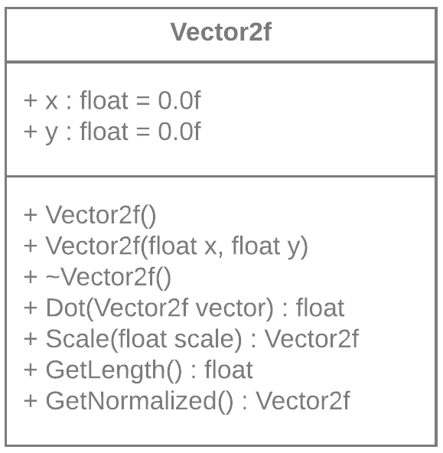
The Vector class consists of two floating point values representing the X and Y axes within the world. This is the class that will be used for the physics simulations as a representation for the vector mathematical type. This class also contains various functions that will be needed in the program to avoid the repeating of math equations in the code. This will improve readability and make the physics model easier to understand.
Figure 10 (Above) – Vector2f

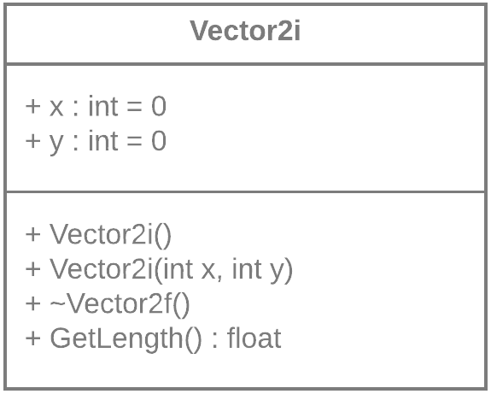
Figure 11 (Above) – Vector2i

The Vector2i class is an integer equivalent of the previous vector class. This class does not require the same functionality as the prior one. This is because this class is used only as an identifier for the spatial grid bucket arrangement.

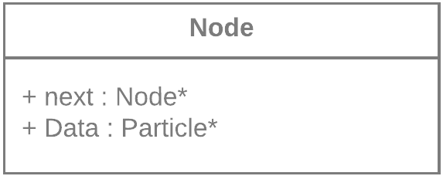
The node class is an implementation of a linked list node. The full list is created in the particle system class. They are used in the particle system to store the pointers to the living and dead particles. A linked list was chosen for this as they are fast as insertion and deletion which is useful for this application as they will only be swapped between lists.
Figure 12 (Above) - Node
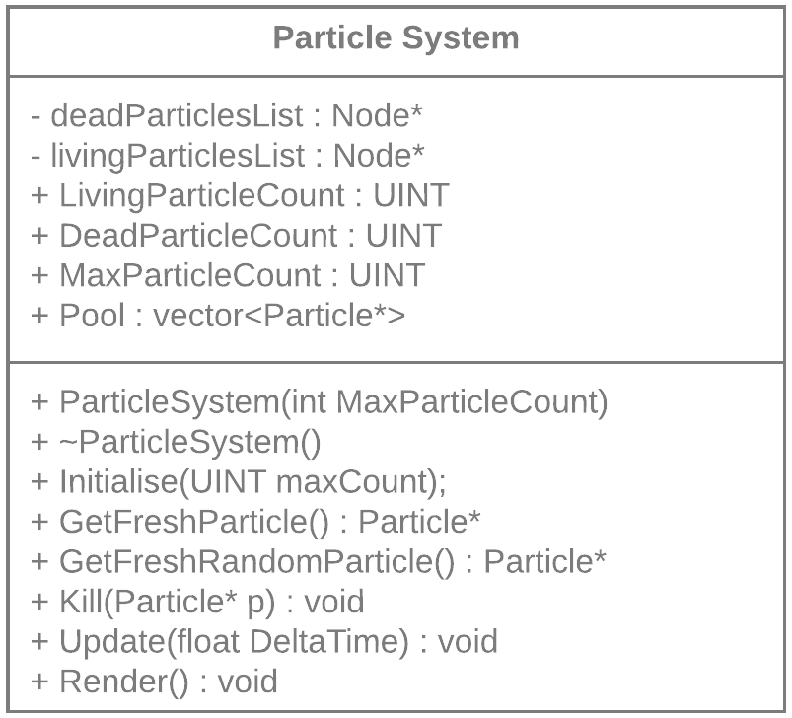
Figure 13 (Above) – Particle system
The particle system class is the heart of the particle simulation. It contains a pool of all the vectors created at the start of the application. The particle pool is a vector as this structure stores the data contiguously meaning that defragmentation is much less likely to occur. The particle class also contains two linked lists, one of all the living particles and the other of all the dead particles. These are used to track the current state of each particle and point to the locations of the particles in the main pool vector. This is so that the location of particles is fast and does not involve iterating through the entire pool.
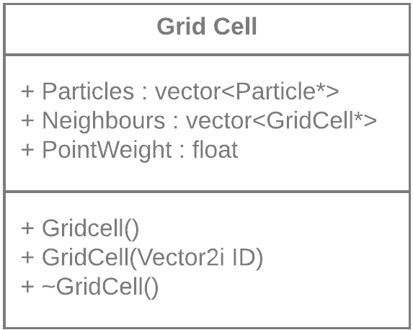
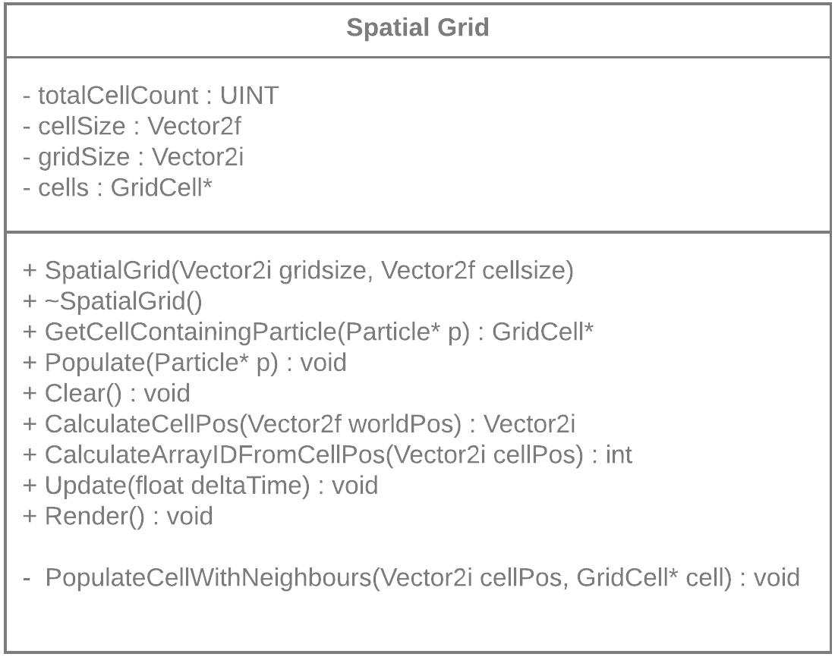
Figure 14 (Above Left) - Spatial Grid Figure 15 (Above Right) - Grid Cell
The Spatial Grid implementation using a singular array of grid cells created in the constructor of SpatialGrid. The pointer array is contiguous and is not accessible externally to avoid the developer from potentially ruining the memory arrangement. It is cleared and populated every frame with particles and calculates the location of the appropriate grid cell which has a vector containing the particles within the cell in that frame. The position of each cell in the array is calculated using the equation:
$$cellOffset = (cellPosition.x * gridSize.y) + cellPosition.y$$

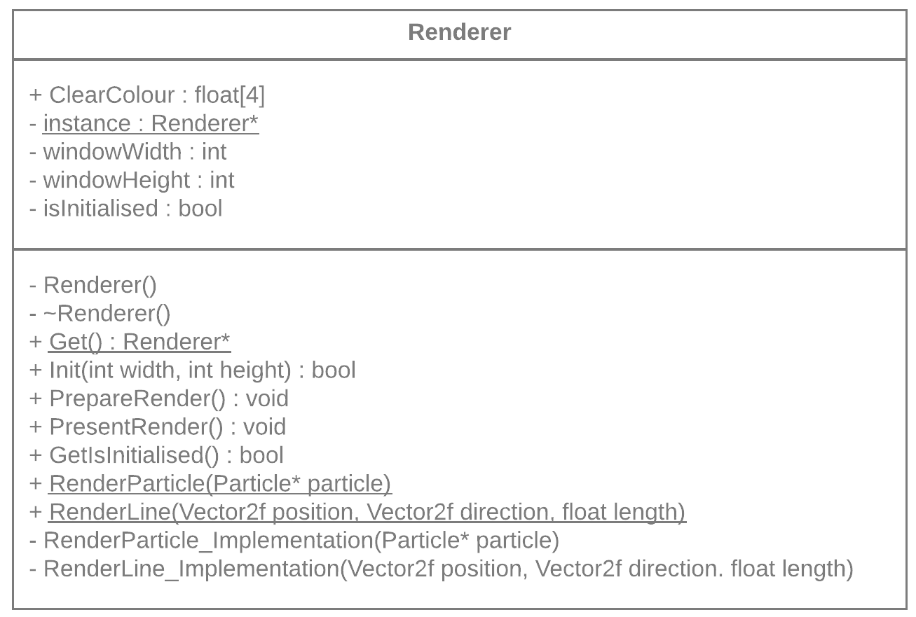
Figure 15 (Above) - Renderer

The Renderer for the program is a singleton, meaning it constants a static instance of itself and ensures that only one renderer will ever exist in the program. A singleton also allows any graphics framework changes to also be isolated only to the Renderer class. This will help in the future should a refactor be required to implement a different graphics API (Trivedi, 2012). It also contains a series of static methods for rendering which have internal implementations that call the instance. These were used to make it easier for the developer to render debug features such as lines or shapes anywhere in the system without needed to pass through the rendering system. It should also help maintaining an easy to understand code base.
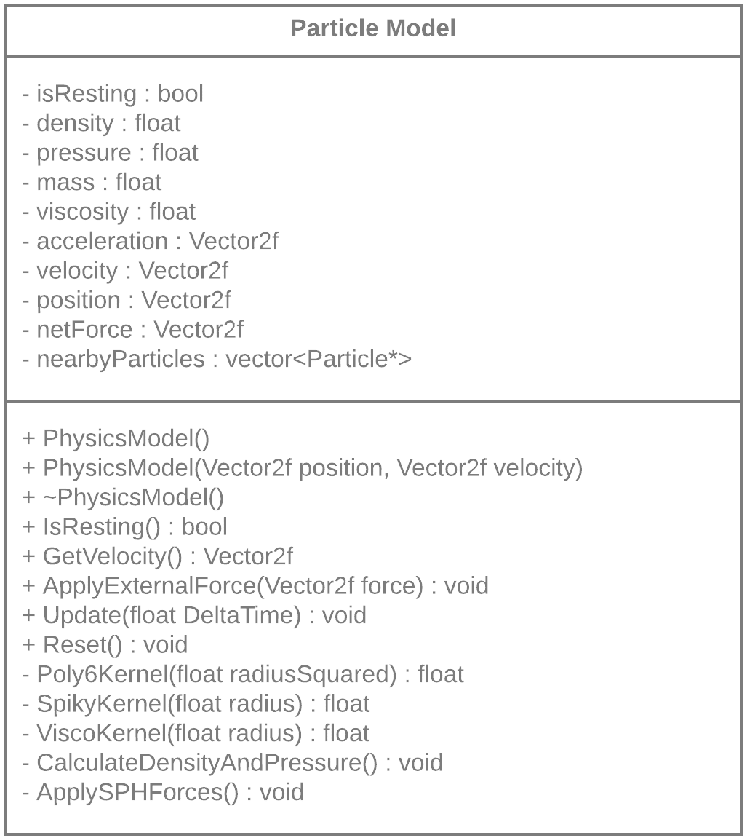
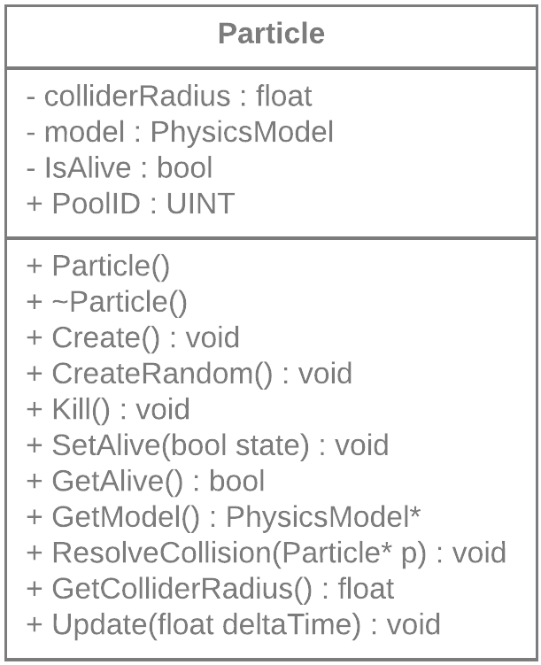
Figure 17 (Above Right) - Particle
Figure 17 (Above Left) - Particle Model

The physics model for each particle has been separated to its own class to make the code easier to understand, as now, everything related to the physics side of the program is differentiated from the particle system side. The model for each particle still has an access function and so the position and velocity data are still accessible to be used in other places, such as collision detection and response. The Kernels are stored as functions in the particle model as that is where the only place in which they will be called.

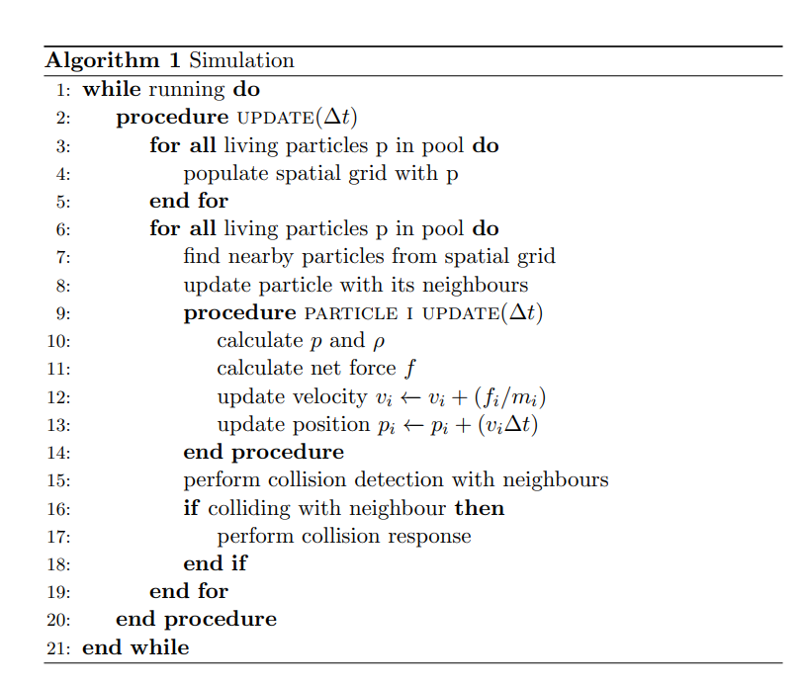
Figure 18 (Above) - Pseudocode of Simulation Process
From the research and the outlines of each class, the simulation process can be drafted. Each frame, the program will loop through each particle and add them to the spatial grid which will sort them into their cells. This must be done before any other frame updates as the method and collision response require an already filled spatial grid for the frame. A method could be implemented to use a dirty flag approach (Nystrom, 2014) for whether to update the spatial grid positions but this is extra complexity that is not necessary and may not have a huge impact on the performance of the project at this level. The simulation then loops through the particle pool again, locates the neighbouring particles to the target particle. It then gives the list of particles surrounding to the target particle and then calls its update function. The particles update function will call the physics model and run the SPH implementation to update the velocity and position of the particle using the surrounding particles given to it a few lines earlier. Finally, the neighbour list is used again, but in collision detection. This occurs post SPH to assure that the particles are not colliding or outside of the world bounds for the next allocation to the spatial grid.

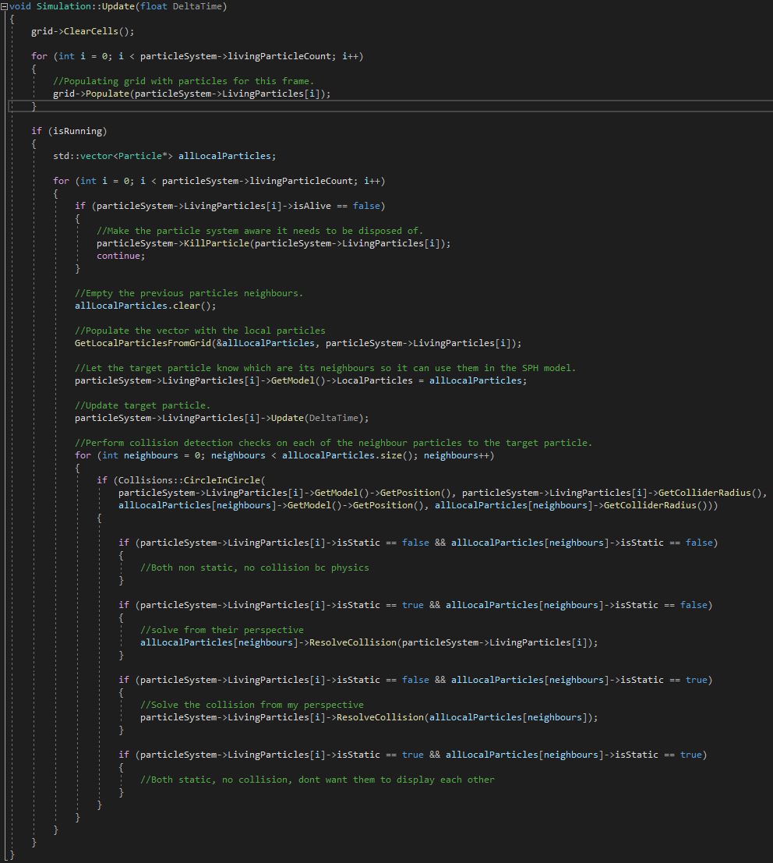
Below is the final implementation of the core simulation loop stated in figure 18.

Testing
Software testing is a process involves investing the quality of a piece of software. It is primarily to discover any potential faults and failures within the software before full development so that they can be rectified. The software testing process can cover several aspects of the deployment of a product. For example, you can test:
- A product’s comparison to its design document requirements.
- Whether the product correctly responds to various inputs entered.
- If the product performs as intended within a responsible timeframe.
- If the product is usable to a sufficient degree.
- Whether the product sufficiently covers the requirements of the stakeholders.
Software testing can occur at the point in which a useable build exists. The pace and extensivity of the testing methodologies are typically determined by the overall project methodology. For example, in an Agile development methodology, the requirements, programming and testing phases are done alongside each sprint to match the pace of the development cycle. The choice of testing methodology can also be affected by the type of project you are producing (Limaye, 2009). A video game would have much different requirements to test for functionally than a program for an insurance calculation program.
The main types of testing are Black Box, White Box, and Grey Box testing (Saleh, 2009).

White Box Testing
White Box testing is testing that occurs on the internal structures created by the developers to meet the requirements set out by the project methodology. This means that when test cases are being produced, they are designed using internal access to the source code. This allows the tester to designate appropriate outputs for the test to ensure all functionality works as intended.
White Box testing is primarily a method of verification and so an advantage of White Box testing is that is can ensure that the proper development procedures were followed throughout the development cycle. It ensures that the coding standards are consistent throughout and there has been no deviation from the set-out development plan. As a verification method, White Box can alert the developers if something is not going to plan. This makes it incredibly cost efficient to use this method as it helps in the reduction of errors in the stages (Limaye, 2009). When using White Box testing as a verification technique though, it can have several disadvantages. For example, White Box testing cannot find unimplemented or missing features. This is because White Box testing will only validate and test the features that are implemented. As well as this, if you are working on a rapidly changing code base then any internal automated test cases can be wasted time and so this method may only be workable for project methodologies that work over long term development cycles (Lee, 2017).

Black Box Testing
Alternatively, Black Box testing covers the testing of external components of a system without access to the internal code of the product. It is typically a representation of the type user-system interaction and an attempt to replicant an active production environment. The tester during Black Box testing should be aware of the expected result of the test but they should not be aware of how the program runs it. Black Box testing usually occurs within companies that have distinct testing teams as this allows them to effectively test without a need for a code proficient team (Limaye, 2009).
An advantage of Black Box testing is that the separation of design and testing teams allow for unbiased testing as they are working entirely independent, leading to a higher quality product. Another positive of using Black Box testing is that it can be started from the beginning of development, as soon as the specification list exists (Moore, 2015). This ensures that the testing team can be at work from the very start. Several tests can only be done using Black Box testing methodologies such as security testing (Limaye, 2009). Black Box testing however has its own drawbacks. For example, if a program has an internal issue that will not reflect on the front end then the test case will succeed but the program is not functioning as intended. This can be compounded by the tester’s lack of knowledge leading to insufficient levels of testing. Black Box test cases are designed based upon the specifications of the project and so without a clear definition from the start, it can be difficult to produce reliable test cases that the client is happy with.

Grey Box Testing
Grey Box testing is a combination of the previous two methods with the intent to locate any defects in either the structures covered by White Box or the improper application use covered in Black Box. A Grey Box tester is partially aware of the programs internal code. This can be through access to the programming documentation detailing algorithms produced for the program (STF, 2020). It is useful to Grey Box test as it allows for a straightforward approach and receive results for both the Black Box and White Box elements (Coulter, 2001).
For this project, the number of shareholders in the project is extremely low and the scope of the project is small and so the depth of the black box testing available is small and so there will be few test cases that can update the front-end interface effectively. As well as this, a core part of the requirements for this program is that it effectively acts like a liquid visually which can be open to interpretation.

Case | Expected Result | Actual Result | PASS
Visually accurate | Provides a visually accurate simulation of a liquid. | Provides a visually accurate simulation of a liquid. | YES
Visually appealing | Provides a visually appealing depiction of a fluid. | Provides a low-resolution depiction of a fluid. | NO
Adding particles to the scene | Visually adds a particle to the scene and increments the particle count UI. | Visually adds a particle to the scene and increments the particle count UI. | YES
Removing particles from the scene | Visually removes a particle to the scene and decreases the particle count UI. | Visually removes a particle to the scene and decreases the particle count UI. | YES
Pausing the simulation | Shows the paused scene and the simulation stops. | Shows the paused scene and the simulation stops. | YES
Shows the paused scene and the simulation stops. | Shows the paused scene and the simulation stops. | Shows the paused scene and the simulation stops. | YES
Scene one is created | Particles reset to a repeatable position on a key press. | Particles reset to a repeatable position on a key press. | YES
Scene two is created | Particles reset to a repeatable position on a key press. | Particles reset to a repeatable position on a key press. | YES
Scene three is created | Particles reset to a repeatable position on a key press. | Particles reset to a repeatable position on a key press. | YES
Simulation visual style changes | The rendering style of the simulation changes on the key press. | The rendering style of the simulation changes on the key press. | YES

As demonstrated in the table above, the program passes nearly every test case. The failed test case involving the visual appeal of the simulation is caused due to an algorithm choice and implementation and is non-vital to the running of the program. Further improvements upon the failed test case are discussed in the conclusion.

Conclusion
Overall, the project had a good outcome despite falling short of the proposal requirements.
In terms of the development process, the Rapid Application Development methodology chosen was the correct choice. It worked well alongside the regular meetings with the supervisor for this project as it allows for the time between these meetings to act as sprints. This has worked very well with the scope of the project. It has also allowed for some flexibility during development which has been vital given the difficulties faced over the project. As well as this, the choice to use OpenGL was a good choice. It allowed for a focus on the physics side of the project more than the graphics systems. The option to use an external library was also a good option. It allowed the development of prototypes to begin very early and has allowed the code base to remain clean and easy to understand as a large amount of code covering graphics device and window setup has been offset.
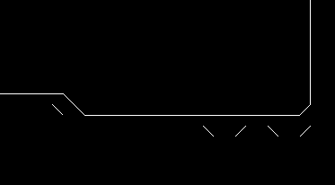
Several minor bugs exist within the program, but the main ones that would be covered in another attempt at the project include:
Figure 19 – Screenshot showing the artifacts.
- Marching Cubes artifacts – When the program is rendering in the Marching Cubes mode, there are a series of artifacts showing that something is wrong with the case rendering or the calculations of the point weight. It could also be caused by the resolution of the grid used in the Marching Cubes rendering.

- Collision Detection issues – There are a few tunneling issues regarding the particles at the edges against the solid walls. When the collision response occurs, it moves the particles inside which leads to a back and forth effect against the wall as the density surrounding the particle changes and SPH tries to resolve it. A solution for this may be to include the solid particles into the SPH model and flag them to not apply forces onto the static objects.

- Adding particles – Adding particles individually can lead to them shooting out of the scene. This is believed to be because of the SPH calculations for density using surrounding particles.

Despite these bugs, the Smoothed Particle Hydrodynamics model produces a realistic looking water effect. As shown by the test case, it is let down however by the Marching Squares implementation which was used instead of the Metaballs approach. It fails to provide a visually appealing depiction, but it is still suitable enough to deduce that it is a simulation of a fluid. At the current resolution of Marching Squares, it just does not accurately show the edges close enough. The detailed particle view however is a useful view for showing the velocity and flow direction of the particles in the water. The program also runs at a sufficient frames per second, producing a clean flow of particles without any frame drops of visual jittering. In the future, there is plenty of room for expansion. For example, implementing the Metaballs algorithm as a shader would dramatically improve the look of the program with little cost to performance as it will be much more optimised to run on the GPU. Another solution for improving the look of the game would be to put the physics code into an existing engine such as Unity. This would have the same effect as using an existing graphics API as the rendering system for an engine already exists. As well as this, it would typically come with an existing collision system which was also provide a solution for one of the bugs in the program regarding the tunneling effect of particles. An existing engine would also be massively optimised and so the project will more than likely always be of a decent FPS.
Individually, the project has deepened my understanding of how physicists approach problems. It has helped with diagnosing and rectifying problems with the SPH method. As well as this, working on a project of this technical depth has helped with my ability to comprehend how technical documentation and scientific reports are laid out and it has also helped with my management skills given the difficulties faced over the project. I would consider the project a success and I am happy to work on it in the future.

References
Anthony, S., 2012. Valve: OpenGL is faster than DirectX - even on Windows. [Online]
Available at: https://www.extremetech.com/gaming/133824-valve-opengl-is-faster-than-directx-even-on-windows
Armstrong, M. et al., 2008. High Frame-Rate Television, s.l.: BBC.
Catano, M., 1989. In: D. F. H. J. H. Michael Catano, ed. The Digital Guid To Software Development. Bedford, Mass: Digital Press, pp. 56-57.
Cormen, T. H., Leiserson, C. E., Rivest, R. & Stein, C., 1989. In: Introduction to Algorithms. s.l.:MIT Press, pp. 253-258.
Coulter, A. C., 2001. Graybox Software Testing Methodology, s.l.: s.n.
Douglas, D. H. & Peucker, T. K., 1973. Algorithms for the reduction of the number of points required to represent a digitized line or its caricature. The Canadian Cartographer, 10(2), pp. 112-122.
Ekstrand, J., 2016. Vulkan in Open-Source. Brussels: FOSDEM.
Encyclopedia Britannica, 2018. Laminar Flow. [Online]
Available at: https://www.britannica.com/science/laminar-flow
Finkel, R. A. & Bentley, L. J., 1974. Quad Trees: A Data Structure for Retrieval on Composite Keys.. Acta Informatica, 4(1), pp. 1-9.
Foley, T., 2015. Next-Generation Graphics APIs: Similarities and Differences. Los Angeles: SIGGRAPH 2015.
Fridman, A., n.d. The Massive Downside of Agile Software Development. [Online]
Available at: https://www.inc.com/adam-fridman/the-massive-downside-of-agile-software-development.html
Gingold, R. A. & Monaghan, J. J., 1977. Smoothed particle hydrodynamics: theory and application of non-spherical stars. Monthly Notices of the Royal Astronomical Society, November, Volume 181, pp. 375-389.
Ginman, V. & Malmros, K., 2013. Visualization of smoke using particle systems, s.l.: KTH Computer Science and Communication.
Gong, S. & Newman, T. S., 2016. Dual Marching Squares: Description and Analysis, Santa Fe: IEEE.
Hastings, E. J., Mesit, J. & Guha, R. K., 2005. Optimization of Large-Scale, Real-Time Simulation by Spatial Hashing. Summer Computer Simulation Conference 2005, SCSC 2005, Part of the 2005 Summer Simulation Multiconference, SummerSim 2005, pp. 9-17.
Kang, L. & Liang, J., 2019. Large Scale Dynamics Visualization On GPU, Beijing: s.n.
Khan Academy, 2019. Introduction to Particle Systems. [Online]
Available at: https://www.youtube.com/watch?v=ovlVh-QgVao
Khronos Group, 2016. Vulkan™ Overview. s.l.:s.n.
Khronos Group, n.d. GLUT and OpenGL Utility Libraries. [Online]
Available at: https://www.opengl.org/resources/libraries/
Kissflow, n.d. Rapid Application Development (RAD) | Definition, Steps and Benefits. [Online]
Available at: https://kissflow.com/rad/rapid-application-development/
[Accessed 27 October 2020].
Knuth, D. E., 1998. The Art of Computer Programming. 2nd ed. s.l.:s.n.
Lee, J., 2017. White-Box Testing: Pros and Cons. [Online]
Available at: https://www.seguetech.com/white-box-testing-pros-cons/
Liang, Z., Yang, X. & Wei, Z., 2010. Design and Implementation of Object Pool Based on J2ME RMS. In: 2010 International Symposium on Intelligence Information Processing and Trusted Computing. s.l.:s.n., pp. 435-438.
Limaye, M. G., 2009. In: Software Testing: Principles, Techniques and Tools. s.l.:TaTa McGraw Hill Education Private Limited, pp. 107-111.
Liu, G.-R. & Liu, M. B., 2003. Smoothed Particle Hydrodynamics. In: Smoothed Particle Hydrodynamics: A Meshfree Particle Method. Singapore: World Scientific Publishing, pp. 26-30.
Lucy, L., 1977. A numerical approach to the testing of the fission hypothesis. The Astronomical Journal, 82(12), pp. 1013-1024.
Maple, C., 2003. Geometric Desing and Space Planning Using the Marching Squares and Marching Cube Algorithms. s.l., s.n.
Meagher, D. J. R., 1980. Octree Encoding: A New Technique For The Representation, Manipulation and Display of Arbitrary 3-D Objects by Computer, New York: s.n.
Microsoft, 2015. MSDN Direct3D 12 Programming Guide. [Online]
Available at: https://docs.microsoft.com/en-us/windows/win32/direct3d12/what-is-directx-12-
[Accessed 28 12 2020].
Moore, W., 2015. What is Black Box Testing: Advantages and Disadvantages. [Online]
Available at: https://www.invensis.net/blog/black-box-testing-advantages-disadvantages/#Disadvantages_Cons_of_Black_Box_Testing
Müller-Fischer, M. & Bridson, R., 2007. Fluid simulation: SIGGRAPH 2007 course notes. s.l., ACM Digital Library.
Müller, M., Charypar, D. & Gross, M., 2003. Particle-Based Fluid Simulation for Interactive Applications, s.l.: s.n.
Munson, B. R., Okiishi, T. H., Huebsch, W. W. & Rothmayer, A. P., 2013. Other Aspects of Differential Analysis. In: Fundamentals of Fluid Mechanics. 7 ed. s.l.:Wiley, p. 331.
NASA, 2014. Reynolds Number. [Online]
Available at: https://www.grc.nasa.gov/www/BGH/reynolds.html
Naz, R. & Khan, M. N. A., 2015. Rapid Applications Development Techniques: A Critical Review. International Journal of Software Engineering and Its Applications , 9(11), pp. 163-176.
Nolla Games, 2020. Noita. Helsinki: Nolla Games.
Nystrom, R., 2014. Game Programming Patterns. In: s.l.:s.n., pp. 414-423.
Nystrom, R., 2014. Object Pool. In: Game Programming Patterns. s.l.:Genever Benning, pp. 305-321.
Olofsson, M., 2016. Direct3D 11 vs 12: A Performance Comparison Using Basic Geometry, s.l.: s.n.
Park, H. & Han, J., 2008. Fast Rendering of Large Crowds using GPU, s.l.: s.n.
Peddie, J., 2012. Who’s the Fairest of Them All?. Computer Graphics World, 35(4).
Pope, S. B., 2000. Turbulent Flows. New York: Cambridge University Press.
Purho, P., 2019. Exploring the Tech and Design of 'Noita'. San Francisco: GDC.
Reeves, W. T., 1983. Particle Systems - A Technique for Modeling a Class of Fuzzy Objects. ACM Transactions on Graphics, 2(2), pp. 91-108.
Saleh, K. A., 2009. In: Software Engineering. s.l.:J. Ross Publishing, Inc., pp. 224-240.
Schuermann, L. V., 2016. Particle-Based Fluid Simulation with SPH. [Online]
Available at: https://lucasschuermann.com/writing/particle-based-fluid-simulation
Smartsheet Inc, n.d. Understanding The Agile Software Development Lifecycle And Process Workflow. [Online]
Available at: https://www.smartsheet.com/understanding-agile-software-development-lifecycle-and-process-workflow
[Accessed 25 October 2020].
S, S., 2017. A Study of Software Development Life Cycle Process Models, Mangalore: s.n.
Star Trek II: The Wrath of Khan. 1982. [Film] Directed by Nicholas Meyer. USA: Lucasfilm Ltd..
Steen, A., 2020. Real-time river simulation using metaballs, s.l.: s.n.
STF, 2020. Gray Box Testing. [Online]
Available at: https://softwaretestingfundamentals.com/gray-box-testing
Swan II, J. E., 1994. Fast Collision Detection with an N-Objects Octree, s.l.: s.n.
Sylvan, S., 2007. Particle System Simulation and Rendering on the Xbox 360 GPU. Göteborg: s.n.
Team, S., n.d. Top 4 software development methodologies | Synopsys. [Online]
Available at: https://www.synopsys.com/blogs/software-security/top-4-software-development-methodologies
[Accessed 23 October 2020].
Trivedi, J., 2012. Singleton Design Pattern. [Online]
Available at: https://www.c-sharpcorner.com/UploadFile/ff2f08/singleton-design-pattern/
Unity Technologies, 2020. https://docs.unity3d.com/Manual/ParticleSystems.html. [Online]
Available at: https://docs.unity3d.com/Manual/ParticleSystems.html
Van Verth, J., 2010. Fluids in Games. s.l.:s.n.
West, C. J., 2018. A Comparison of Software Project Architectures: Agile, Waterfall, Spiral and Set-Based, s.l.: s.n.
Witkin, A., 1997. An introduction to physically based modeling: particle system dynamics. SIGGRAPH Course Notes.
Wong, J., 2014. Metaballs and Marching Squares. s.l.:s.n.
Wongpanich, A. & Jow, O., n.d. Position-Based Fluid Simulation. [Online]
Available at: https://owenjow.xyz/graphics/1845/#technical
Zhang, B. & Hu, W., 2017. Game Special Effect Simulation Based on Particle System of Unity3D. s.l., s.n., pp. 595-598.
Zodiac. 2007. [Film] Directed by David Fincher. USA: Phoenix Pictures.

